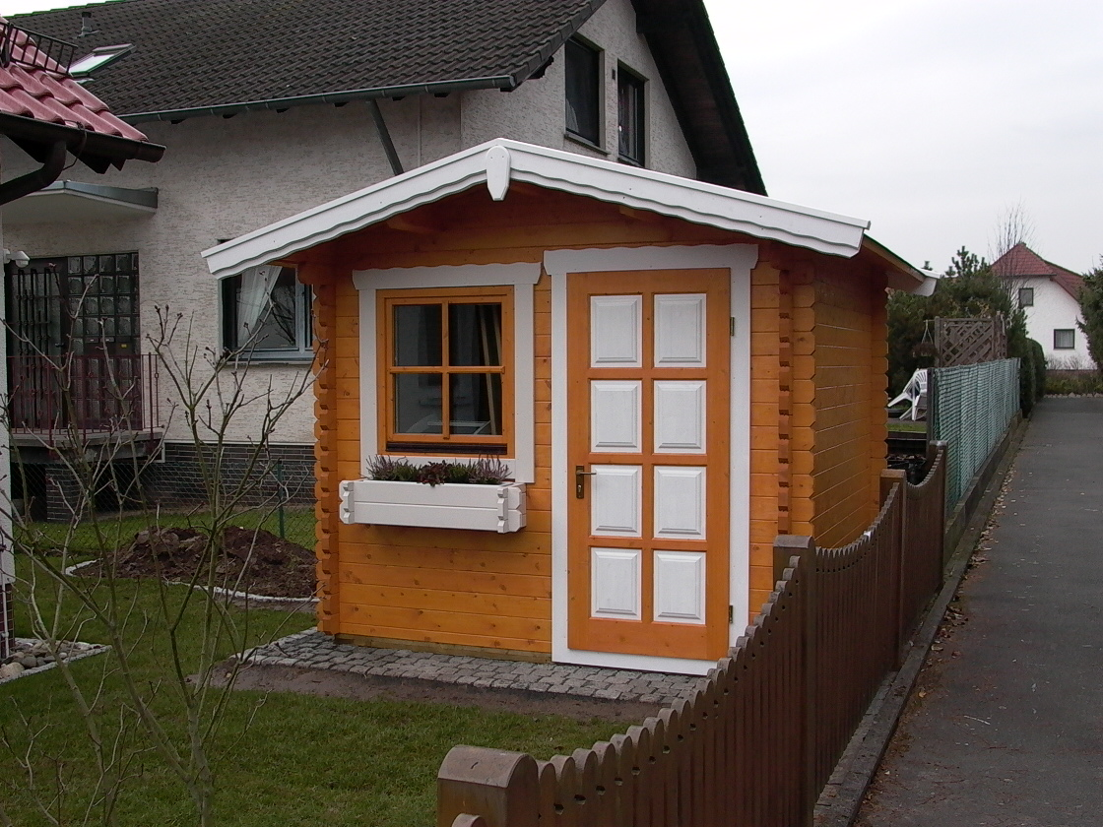  Nida - B: 3m x T: 3m | 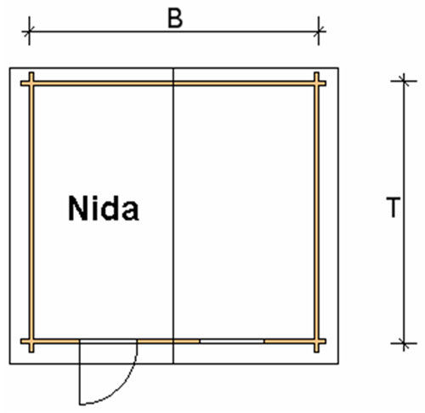
 | 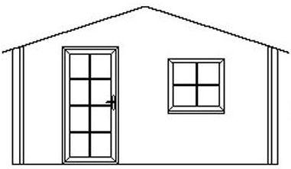

Nida Log Cabin
Roof projection: Front 0.70 m
Back 0.20 m
Side 0.30 m

Walls: 45 mm or (60 mm glued) double tongue and groove logs
Floor: 20 mm tongue and groove floor boards on the impregnated base frame
Roof: 20 mm tongue and groove roof boards
Door: 1 glued cartridge door 90/196 with seal
Windows: 1 double-glazed 80/94 tilt ‘n‘ turn unit

Size (m) |  | Price (£) |  | Optional Extras
 |  |  |  | Roof Insulation (£) |  | Shingles (£)
B | T | 45 | 60 | 45 | 60 | Shingles (£)
3 | 3 | 1909 | - | 90 | - | 121
3 | 4 | 2281 | - | 108 | - | 145
4 | 3 | 2281 | - | 108 | - | 145
4 | 4 | 2675 | 3383 | 130 | 132 | 170
4 | 5 | 2978 | 3765 | 147 | 149 | 218
5 | 4 | 3024 | 3447 | 152 | 154 | 218
5 | 5 | 3358 | 4324 | 172 | 173 | 250
Extras:

Single window £83
Double window 1200/940 £124
Single door £159
Double door 1700/1970 £267

